**jQuery questions.**

Describe how to include jQuery inside a website

1. You can add it as a script tag on the head of your HTML file.

Example: <script src="jquery-3.2.1.min.js"></script>

1. As a CDN with Google or Microsoft:

<script src="https://ajax.googleapis.com/ajax/libs/jquery/3.2.1/jquery.min.js"></script>

Describe jQuery selectors

Basic syntax is: **$(*selector*).*action*()**

* A $ sign to define/access jQuery
* A (*selector*) to "query (or find)" HTML elements
* A jQuery *action*() to be performed on the element(s)

Selectors are used to manipulate and select HTML elements

#id Selector

You select the element like this: $("#test").hide();

#class Selector: $(".test")

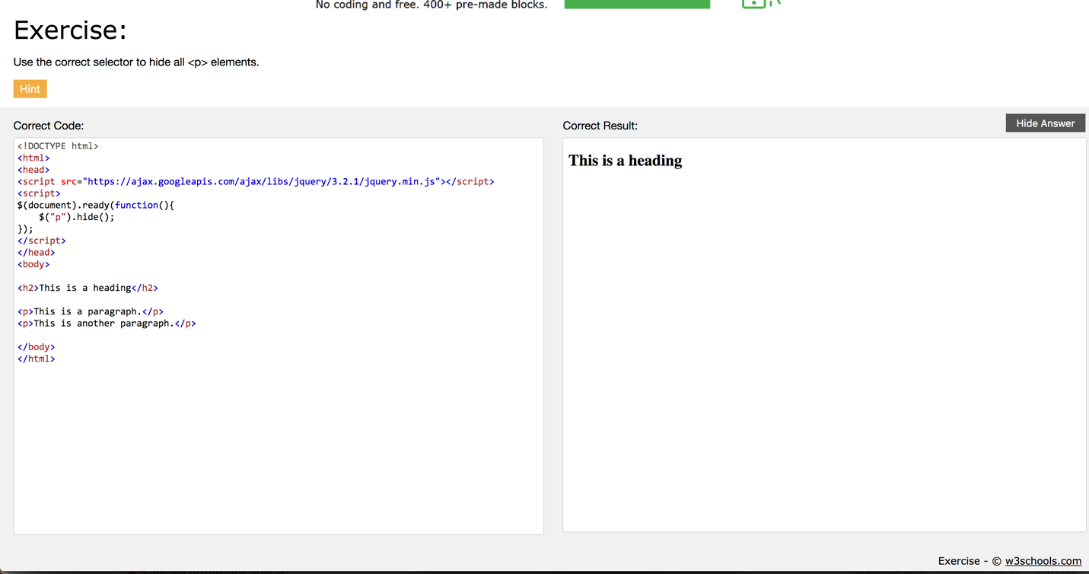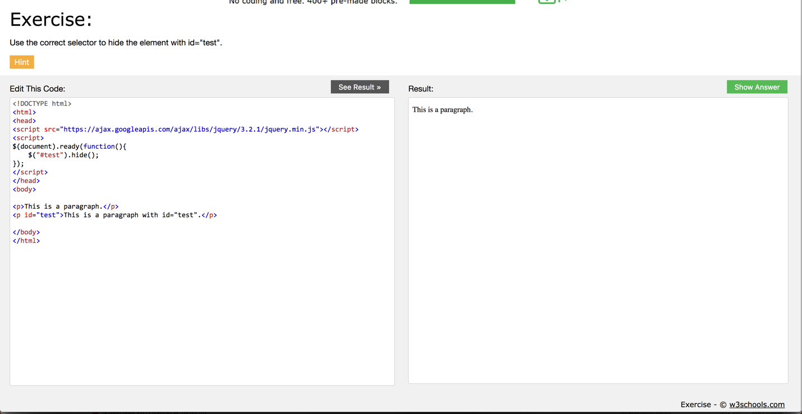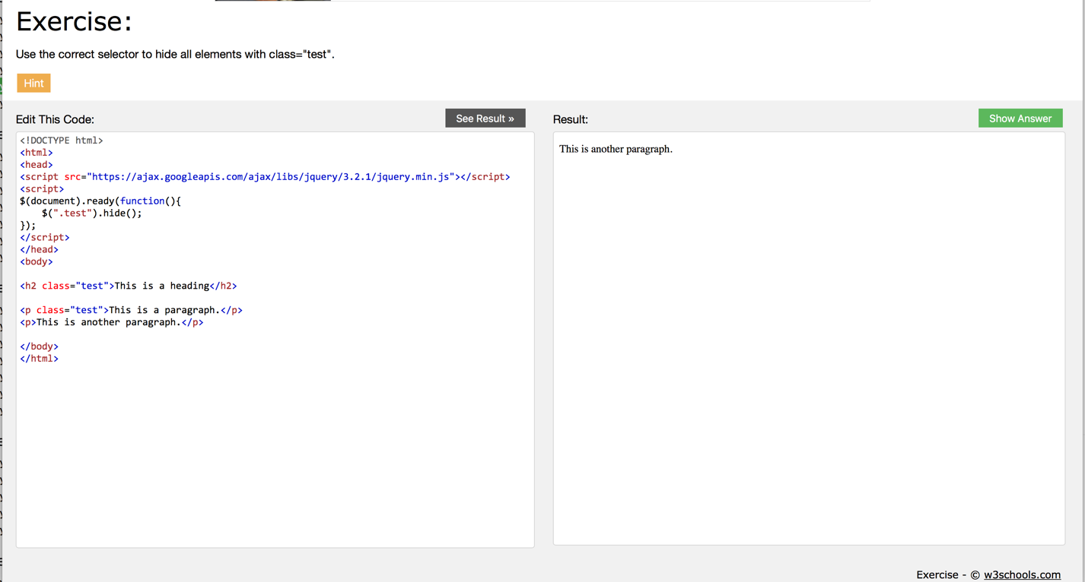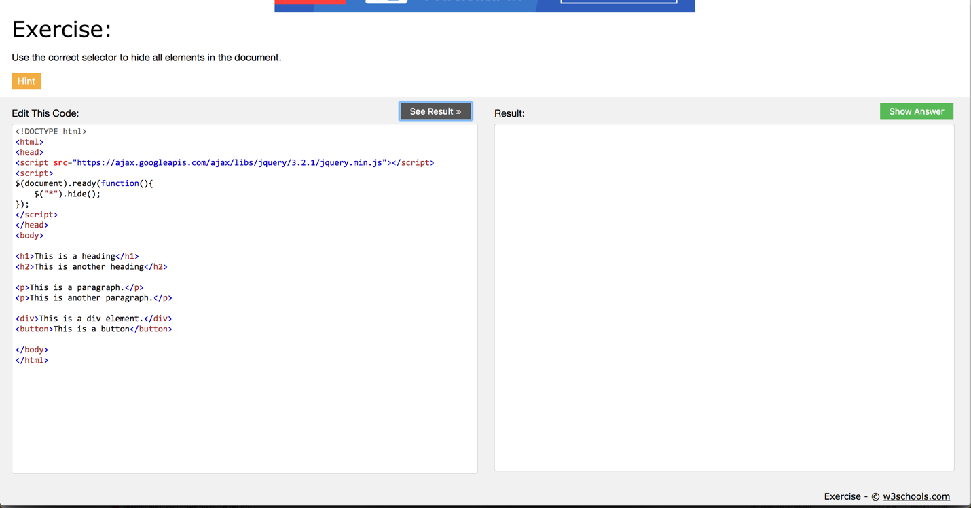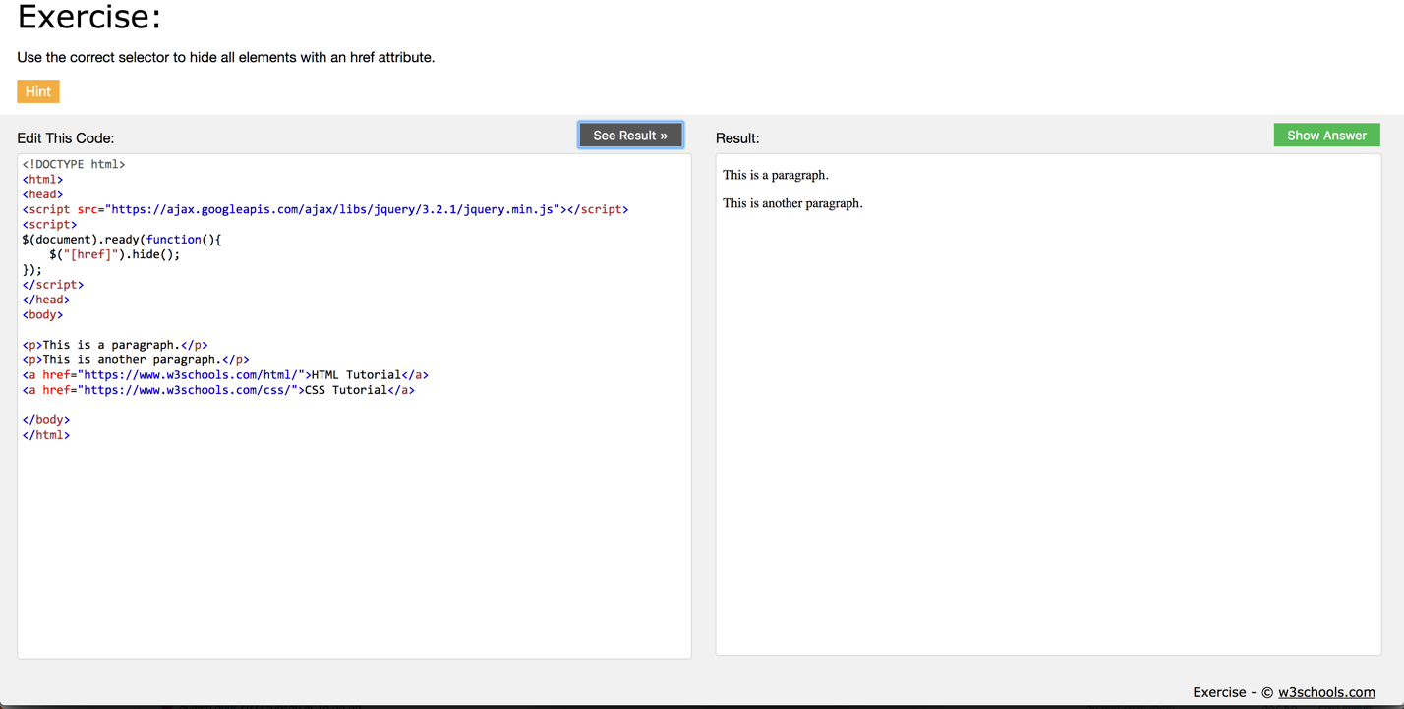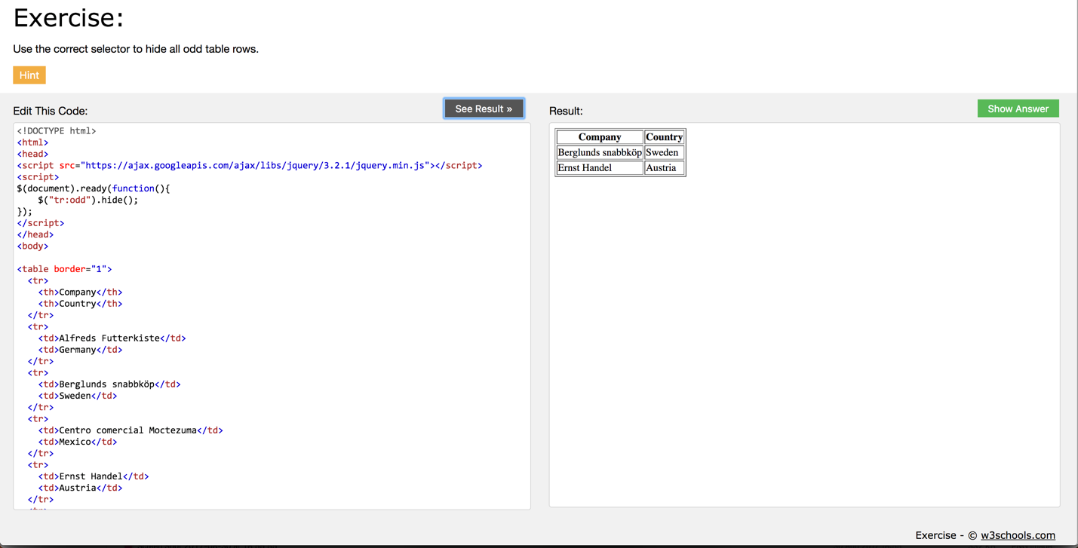

Describe how to call jQuery methods, show five examples

You select an element then add a “.” and then a method like:

Examples:

.hide();

.blur();

.change();

.focus()

.hover()